South African Risk and Vulnerability Atlas

Kruger to Canyons Case Study

**Adapting to climate change in a diverse landscape: the Kruger-Canyons Biosphere Reserve**

**Davis C, Archer E, Maserumule R, Stevens N and Sinden L**

*Abstract*

*The Kruger to Canyons study area (K2C) was designated as a Biosphere Reserve under UNESCO to preserve the integrity of the conservation areas while improving the livelihoods of the people who live within its borders. The case study is focused on the highly diverse land use area of K2C where a range of stakeholders are active, including Bushbuckridge Municipality, South African National Parks, Mpumalanga Parks Board, the previously named Department of Water Affairs and Forestry (DWAF) and a range of civil society initiatives. Previous studies indicate that global changes in the area may already be occurring with critical impacts expected in water supply and quality, commercial agriculture, forestry, health, communal rangelands, livestock, and conservation sectors. This study will draw on the findings of a significant amount of research that has already taken place in the area with an aim to engage stakeholders in the development of an information system focused on climate change adaptation.*

1. **Introduction**

Southern Africa is predicted to be severely affected by future climate change, and hence is considered a priority area for creating an enabling environment for adaptation. There is now clear observational evidence that shows that many natural systems are being affected by increases in air and ocean temperatures as well as fluctuations in the amount and timing of rainfall events, which are in turn likely to have significant implications for human well-being (IPCC 2007). Understanding climatic changes and their possible impacts on society is essential in critical sectors in South Africa to improve strategic adaptation responses. Given the general consensus in the scientific community on the existence of climate change the question has shifted from: ‘Will we have to deal with the consequences of climate change’ to ‘How should we adapt to the changes which are most likely to occur’.

Climate change is currently becoming increasingly prominent in the science and policy communities, with a corresponding increase in the amount of attention directed to conducting realistic impact and adaptation studies at various spatial and temporal scales. The Kruger to Canyons study area displays a substantive topographic and climatic diversity, and is the site of multiple stressors, making it an excellent subject for considering how climate change impacts might be successfully managed in a diverse landscape.

***Kruger to Canyons Biosphere Reserve***

The Kruger to Canyons study area (Fig 1) of northeast South Africa was designated as a Biosphere Reserve under UNESCO in 2001 to preserve the integrity of the conservation areas while improving the livelihoods of the people who live within its borders. More broadly, the primary goal of the Kruger-Canyons Biosphere Reserve initiative is to “...continue with conservation in the already protected areas; to improve conservation awareness...Biosphere Communities and attempt to coordinate conservation activities...amongst the different land uses.” (Central Lowveld LEAP: Final Report 2000, pg 68). One of the consequences of conservation initiatives in the past has been the economic underdevelopment of rural areas adjacent to conservation areas in certain situations. While management decisions have shown significant progress for both the rural community and the conservation areas, much effort will have to be expended in the future to deal with the challenges brought to bear by climate change.

**Figure 1: The Kruger to Canyons area, encompassing the Kruger to Canyons Biosphere Reserve (a conservation planning exercise for the sub-region) is an excellent example of a landscape where highly diverse land uses occur in close proximity, including state managed conserved areas, privately owned conserved areas, commercial forestry, intensive commercial agriculture such as fruit farming, and both commercial and communal rangeland. (Source: Kruger to Canyons)**

***The impact of climate change on ecosystems and biodiversity***

Southern Africa houses a wealth of biodiversity, being the third most biologically diverse country in the world. The Kruger to Canyons study area is home to 72% of the bird species in South Africa and 64% of the mammal species in South Africa. According to the Millennium Ecosystem Assessment, climate change will be one of the main drivers to alter ecosystem health (structure and function) and biodiversity (the variety of species). The benefits that humans derive from a healthy ecosystem are seen in the regulation of climate, floods, diseases, water quality and pollution. Cultural services include recreational, aesthetic, and spiritual benefits. One of the possible consequences of climate change for the Kruger-Canyon Biosphere Reserve may be a shift or change in the ecosystem goods and services, such as the availability of below ground water and soil nutrients, which ultimately help support the quality of the people’s lives living in the rural communities (Fig 2).

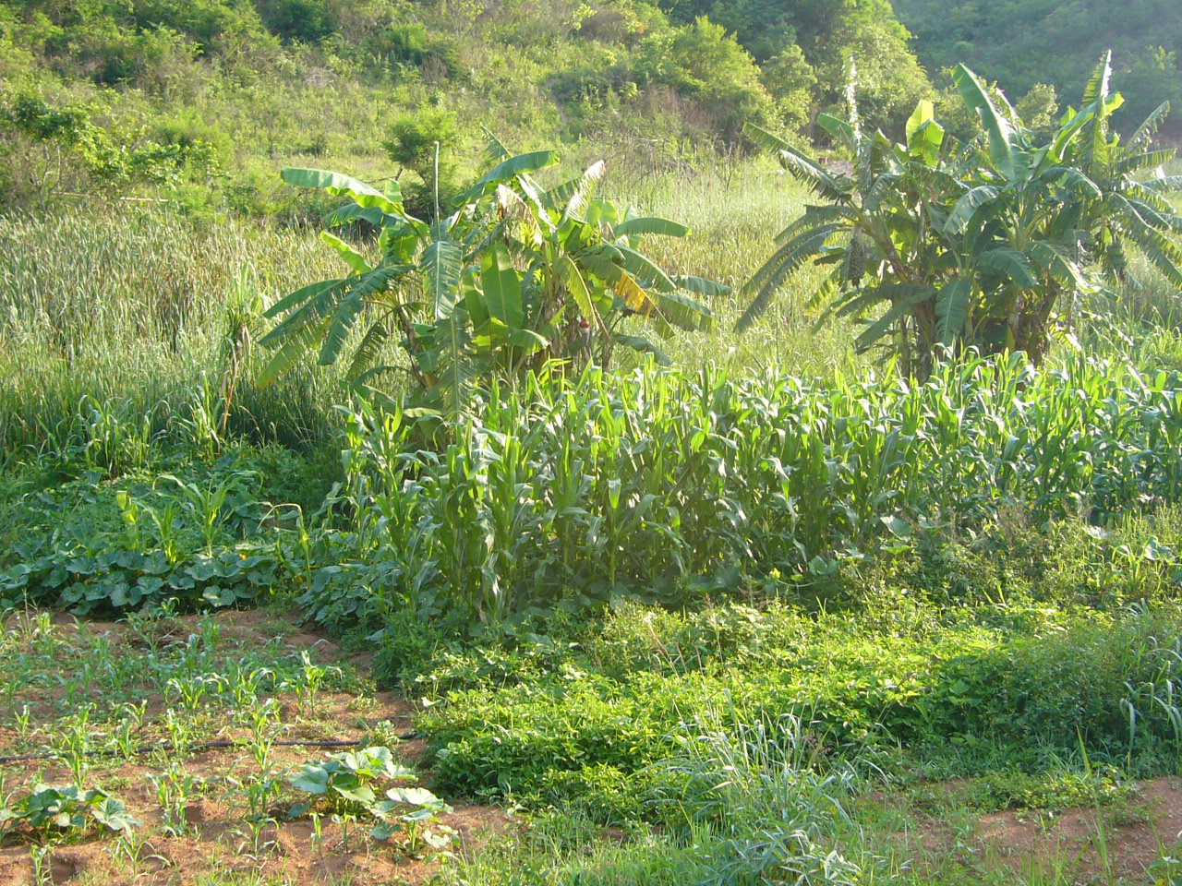

**Figure 2: The size and timing of climatic changes could negatively impact the ability of subsistence farmers to produce food, such as mielies and madumbis, of sufficient quality and quantity** (Craigieburn Wetland, Bushbuckridge Municipality, Mpumalanga).

The rainfall and temperature projections obtained from the SAEON workshop on high-resolution climate data for southern Africa ([www.csag.uct.ac.za/gisdata](http://www.csag.uct.ac.za/gisdata)) provide an example of the predicted changes in climate for the Kruger to Canyons Biosphere area. The MM5 and PRECIS downscaled global climate models project an increase in mean annual temperature of 3.17 ◦C and 3.6 ◦C respectively for the Skukuza savanna system of the Kruger National Park (Fig 3a). From the anomalies projected by the ECHAM downscaling it is expected that by 2080 the mean annual rainfall for the Skukuza region will be 1089mm, which is a doubling of the current rainfall regime. The MRI_CGCM downscaling projects the least amount of change in rainfall (Fig 3b) with a mean annual value 672mm by 2080 for Skukuza. All six statistical downscalings project that rainfall will increase with negative rainfall anomalies only projected for the winter months (Fig 3b). The mean annual rainfall for both regions calculated from the projected anomalies from the other four downscalings range between 600mm and 700mm, which represents a moderate change in future rainfall as these values fall between the extreme predictions of the ECHAM and MRI_CGCM downscalings (Fig 3b).



1. Temperature



1. Rainfall

**Figure 3: (a) The projected annual temperature (◦C) trend for the Skukuza savanna system obtained from the MM5 (green line) and PRECIS (red line) regionally downscaled global climate models. The current (1970-2000 reference period) annual temperature trend (◦C) is represented by the blue line. (b) The projected annual rainfall trend (mm) for the Skukuza savanna system obtained from the six statistically downscaled global climate models with the MRI_CGCM (green line) and PRECIS (red line) projections highlighted. The current (1970-2000 reference period) annual rainfall trend (mm) is represented by the dark blue line.**

1. **The Case Study**

This project is focused on the highly diverse land use area of the Kruger-Canyons Biosphere in northeast South Africa, an area where a range of stakeholders are active, including Bushbuckridge Municipality, South African National Parks, Mpumalanga Parks Board, the previously named Department of Water Affairs and Forestry (DWAF) and a range of civil society initiatives. By incorporating state conserved land, communally managed nature reserves, communally grazed areas, former homeland type dense settlement areas, commercial agriculture, private conserved areas, commercial forestry and provincial conservation (Fig 4), the area is highly appropriate to demonstrate the potential benefits of more accessible information on climate change projections and risk and vulnerability planning around potential impacts for the area.

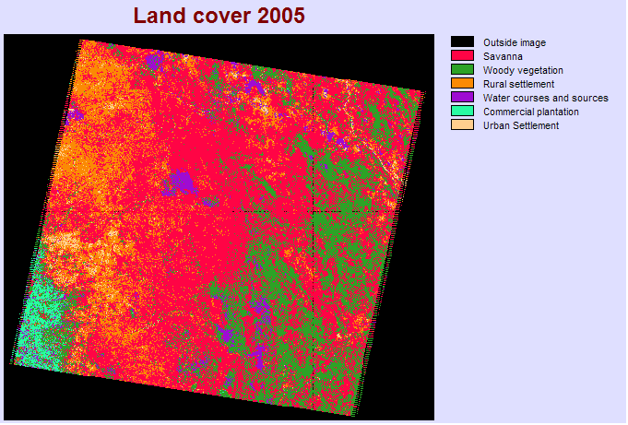

**Figure 4: Land cover map of the Kruger to Canyons Biosphere area obtained from an unsupervised classification technique of a 2005 Landsat-Thematic mapper (TM) image taken in July (bands 1-5).**

Previous studies indicate that climate changes in the area may already be occurring (Fig 5). Any future climate change needs to be considered against a background of possibly existing change; within the aforementioned context of existing multiple stressors, such as increasing water demands. The areas of key impacts critical impact thus include:

* Water supply and quality
* Commercial agriculture
* Forestry (including the reversion of commercial forestry of certain areas)
* Health
* Commercial rangeland management
* Communal agriculture and livestock.
* Conservation management at the landscape scale (Kruger National Park)



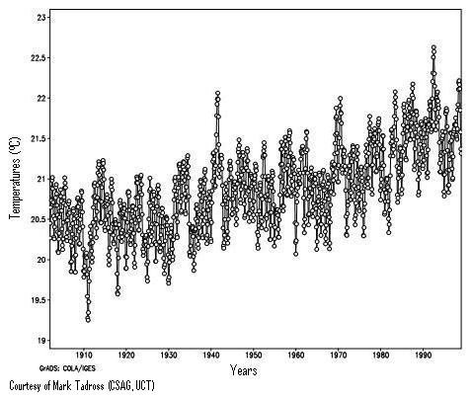

**Figure 5: While long-term trends in precipitation are not evident in the climatic record (top), temperature increases may be apparent (bottom) within the Kruger to Canyons Biosphere area. Rainfall graphs from Sinden, Archer and Tadross (under review).**

Poor communities are seen as the most vulnerable to changes in climate as they have limited adaptive capacities and are more dependent on climate-sensitive goods and services such as the quality and sufficiency of water and food resources. Part of the Kruger to Canyons area comprises former homeland areas, with an accordant backlog of service delivery and infrastructure as well as a considerably great health burden (60% HIV infection rate and chronic lifestyle diseases in the area, such as strokes, diabetes and heart attacks). These communities have a high dependence on natural resources as they provide a free or cheap alternative to other commercial commodities. The most common uses include wooden utensils, grass and twig handbrooms, fuelwood, wild herbs, wild fruit and edible insects (Twine et al., 2003). The sale of marula beer, for example, has been shown to be a vital source of income to several hundred households (Shackleton 2004). These resources, however, are already under increasing pressure from changing environment conditions and socio-economic characteristics, which could ultimately increase affected community vulnerability to future climate change.

Adaptation and mitigation strategies that can be put in place for the area need to draw strongly on what initiatives and strategies currently exist. A number of key initiatives in the area already exist that have multiple benefits, including indirect beneficial effects for adaptation to climate change; or mitigation thereof. Support needs to be provided to such initiatives, where they accomplish multiple objectives at the same time. Examples include civil society work on water access and improved water quality, activities supporting public health infrastructure and public health solutions, and strategies supporting rural livelihoods that simultaneously have adaptation to climate change, as well as carbon sequestration benefits (community wetland restoration and afforestation initiatives, such as Working For Wetlands, and Working for Water, as well as support for appropriate ecotourism and sustainable agriculture are good examples here).

Local government needs to be strongly supported in terms of building capacity to understand the implications of climate change for the area, and to come up with adaptation and mitigation strategies that are integrated into existing initiatives. Secondly, other stakeholders in the area such as the private sector, conservation managers and provincial government need to be similarly capacitated, working in a co-learning environment (i.e. not in isolation) to build on existing activities that build resilience to climate risk and/or achieve mitigation objectives, observe new opportunities; and consider strategies that fulfil multiple objectives.

1. **Description of Scientific Output**

Stakeholders to be involved in the process (stakeholder mapping process currently underway) include Bushbuckridge Municipality, South African National Parks, Mpumalanga Parks Board, and commercial agricultural entities in the area, the Department of Water Affairs, and relevant civil society initiatives. It is hoped that the outputs of this project will include diverse stakeholder planning and decision-making for the Kruger-Canyons area, which is more directly informed by climate change predictions, and improved resilience of such sectors under climate change. Improved resilience of such sectors directly addresses societal need in the form of addressing potential adverse impacts of climate change.

To date, there has been a significant amount of research undertaken in the area directly on or relevant to climate change. This study will draw on the findings of existing research, including student theses, which have already taken place within the Kruger-Canyons Biosphere. Selected examples are provided below (a substantive literature and research review comprises one of the research activities for this study):

* Coetzer et al. (2009) found that within the Kruger-Canyons Biosphere the land area defined as settlement has shown a net increase over time where existing settlements are expanding rather than new ones being established. The majority of these expansions have occurred in degraded vegetation, which has increased over the analysis period.
* Wessels et al. (2004) used AVHRR-derived normalized difference vegetation index (NDVI) data to compare degraded rangelands associated with communal areas to intact rangelands in northeastern South Africa. They found that the degraded areas were not less stable or resilient than adjacent nondegraded areas, but productivity per unit rainfall was significantly reduced. In another study Wessels et al. (2007) in the Limpopo Province suggested that degraded areas produced less forageper unit rainfall received and confirm that degradation rates are consistently highly in the communal areas of the province.
* An NDVI image for the Kruger to Canyons Biosphere area (Fig 6) clearly shows the commercial plantation having the highest NDVI values The area classified as urban land cover by the supervised and unsupervised classification approaches was clearly shown in 2001 NDVI image to have less vegetation than the conserved areas (Fig 6).

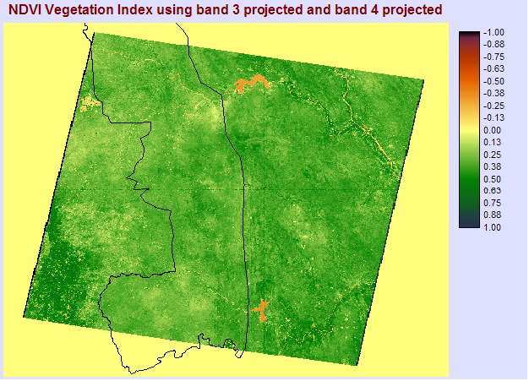

**Figure 6: Normalized Vegetation Index (NDVI)** **of the Kruger to Canyons Biosphere area obtained from a 2001 Landsat-Thematic mapper (TM) image taken in April (bands 1-7).**

* Within the private and state conserved area, it is predicted that numerous structural and functional variables, such as tree and grass biomass, flora and fauna composition, regional hydrology, and soil nutrient fluxes, will respond to future climatic changes (Scholes 2006). Rainfall and temperature are primary determinants of such savanna systems as they control the amount of primary production through the regulation of soil moisture and consequently they regulate the impact of fire and herbivory. Increases in temperature beyond the optimum for net photosynthesis could result in a decrease in productivity and at extreme temperatures leaf damage can occur (Scholes 2006). Elevated temperature conditions, which increase evaporative water losses, have been shown to accentuate the dry season aridity thereby reducing the effectiveness of wet season rainfall in sustaining and promoting vegetation growth (Ogutu and Owen-Smith 2003). The general patterns of change in ungulate populations are correlated to rainfall patterns (Fig 7). Ogutu and Owen-Smith (2003) demonstrate that reductions particularly in dry season rainfall have a more significant influence on population levels than rainfall during the wet season. Wet season rainfall determines the extent of vegetation growth and hence the annual food production for large herbivores. Dry season rainfall extends the availability of palatable foliage through this critical season. Grazers were found to be more affected by annual rainfall variability than browsers because the grass layer responds more strongly to annual precipitation than the woody component of savanna vegetation (Ogutu and Owen-Smith 2003).



Figure 7: The population size of roan antelope in the Kruger National Park, South Africa over a period of 30 years in relation to the annual rainfall and the 5 year mean rainfall for the region (J. Cain 2007 unpublished data).

* An increase in woody plant cover, termed bush encroachment, has primarily been investigated in association with elevated carbon dioxide through two mechanisms. Firstly, at higher atmospheric carbon dioxide concentrations plants generally use less water reducing the rate of transpiration. This means that more water is available in the soil enabling deep rooted plants such as shrubs to increase their productivity as well as their competitive dominance (Bond and Midgley, 2000). Secondly, Bond et al. (2003) suggest that higher rates of atmospheric carbon dioxide will have positive effects on the post-fire re-growth of woody plants, which would result in an increase in woody plant cover. This effect however, depends on the fire regime where a reduction in fire intensity is expected to result in a shift towards increase tree production whereas higher fire intensities are expected to stimulate more grass production (Davis 2008). This, however, is in ongoing debate where findings still need to be validated.
* Davis (2008) modelled the impact of climate change on the savanna systems of the Kruger National Park and concluded that the influence of fire and elephants can, under certain circumstances, overwhelm the negative effects of increased temperature. This demonstrates that existing conservation management decisions are an essential component of climate change adaptation strategies for this area.
* Sinden (2007) investigated the impacts of increases in temperatures and changes in rainfall on a two fynbos climate indicator species, *Eumorphia davyi* and *Widdringtonia nodiflora*, on Mariepskop Mountain in Mpumalanga. Few studies of these species have been conducted, and the fynbos species on Mariepskop have not been mapped. It is essential to study the fynbos species on Mariepskop because of the uniqueness of fynbos, the limited literature pertaining to the fynbos on Mariepskop, and the probable movement of these species in the future. It is also necessary to evaluate the potential for future migration of the species farther up the mountain.

1. **Lessons Learnt**

The project is ongoing, and lessons to be learnt are in progress. The team’s initial communications have indicated is that there is a strong desire in the Kruger to Canyons area amongst diverse stakeholders to access both climate change information, as well as to interactively develop an understanding of what climate change implies for critical sectors in the area. Learning drawn more broadly from the Atlas process, as well as interaction with the South African Local Government Association (SALGA) indicates that no assumption of how the Atlas information will be useful to decision-makers can be undertaken independent of understanding of how users in the area are, and are not able to use such information, as well as how their access and format preferences.

Further, relevant experience in the area prior to this particular project indicates that interaction with and iterative orientation with stakeholders in the area as a follow up to initial user surveys in critical, to avoid the ‘front end loader’ approach to technology transfer (in this case, in the provision of information residing in the Atlas, but this certainly applies in other technology and/or information transfer case study in the study area and more broadly). Lastly, iterative liaison and orientation with stakeholders in the area around the Atlas improves the desired possibility that stakeholders themselves may become active members of the Atlas user community, both using more generic information provided through the Atlas portal, and sharing their own spatial and non-spatial information. Benefits derived from information produced through the case study accrue thus to all stakeholders engaged with in the area, as well as to making the Atlas itself a more user driven process. Decisions informed by the research will be tracked and monitored in partnership with relevant stakeholders.

1. **Links to the Atlas**

The information produced in the study is relevant to the Risk and Vulnerability Atlas since it consolidates the latest findings regarding climate change impacts on key sectors in the area (biodiversity, water, health and livestock production, for example). Such information, made available through the Atlas in spatial and non-spatial format, begins to serve the increasing requests by stakeholders in the area for information regarding climate change impacts on key sectors in the area. The information may be organized under biodiversity, water, health and agriculture (as examples); indicating within all these Atlas sectors critical climate change impacts. Downscaled climate change projections are obviously derived through the climate change data portals linked to the Atlas.

We expect that certain sectors will show few studies indicating climate change impacts and implications (health impacts are likely to comprise a gap, for example). The proposal to be developed at project end will address, in part, a strategy to encourage investigation of climate change impacts for sectors not yet substantively investigated in a climate change context in the Kruger to Canyons area. Data sharing opportunities are significant – as described above, we hope that stakeholders in the area will become active Atlas community users, both accessing more generic information, translating and interpreting such information for their unique contexts and sectors, and further providing such value added information back to the Atlas community, for co-learning.

*References*

Bond W.J. and Midgley GF (2000) A proposed CO2-controlled mechanism of woody plant invasion in grasslands and savannas. Global Change Biology 6:865-869.

Bond WJ, Midgley GF and Woodward FI (2003) The importance of low atmospheric CO2 and fire in promoting the spread of grasslands and savannas. *Global Change Biology* 9:973–982.

Coetzer K, Erasmus BFN and Witkowski ETF (2009) Land cover change in the Central Lowveld and Surrounding Areas. Presenation at Savanna Netowrk Meeting 2009, Skukuza, Kruger National Park, South Africa.

Davis C (2008) Predicted changes in the savanna ecosystems of South Africa as a result of climate change induced carbon dioxide, temperature and rainfall anomalies. Honours thesis, School of Geography, Archaeology and Environmental Studies, University of the Witwatersrand, South Africa.

Ogutu JO and Owen-Smith N (2003) ENSO, rainfall and temperature influences on extreme population declines among African savanna ungulates. *Ecology Letters* 6:412-419.

Scholes RJ (2006) Impacts and Adaptations to Climate Change in the Biodiversity Sector in Southern Africa. A Final Report Submitted to Assessments of Impacts and Adaptations to Climate Change (AIACC), Project No. AF 04.

Shackleton CM (2004) Livelihood benefits from the local level commercialization of savanna resources: a case study of the new and expanding trade in marula (*Sclerocarya birrea*) beer in Bushbuckridge, South Africa. *South African Journal of Science* 100:651-657.

Sinden, L (2007) Impacts of Climate Change on Two Fynbos Species on Mariepskop Mountain,Mpumalanga. Honours thesis, School of Geography, Archaeology and Environmental Studies, University of the Witwatersrand, South Africa.

Solomon S et al (2007) Technical Summary. In: Solomon S, Qin D, Manning M, Chen Z, Marquis M, Averyt KB, Tignor M, Miller HL (eds) Climate Change 2007: The Physical Science Basis. Contribution of Working Group I to the Fourth Assessment Report of the Intergovernmental Panel on Climate Change. Cambridge University Press, Cambridge, United Kingdom and New York, NY, USA.

Twine W, Moshe D, Netshiluvhi T and Siphugu, V (2003) Consumption and direct-use values of savanna bio-resources used by rural households in Mametja, a semi-arid area of Limpopo province, South Africa. *South African Journal of Science* 99:467-473.

Wessels, KJ et al. 2007. Relevance of rangeland degradation in semiarid Northeastern South Africa to the nonequilibrium theory. Ecological Applications, Vol. 17(3), pp 815-827.

Wessels, K.J., Prince, S.D., Frost, P.E., van Zyl, D. 2004. Assessing the effects of human-induced land degradation in the former homelands of northern South Africa with a 1km AVHRR NDVI time-series. Remote Sensing of Environment 91, 47–67.